Swarm Information Foraging to Develop Forest Inventories

Dhruva Arun  Naval Research Laboratory  Laboratory for Autonomous Systems Research  Washington DC, United States | Loy McGuire  Naval Research Laboratory  Laboratory for Autonomous Systems Research  Washington DC, United States | Donald Sofge  Naval Research Laboratory  Laboratory for Autonomous Systems Research  Washington DC, United States

Abstract—This study addresses the challenge of accurate wildfire behavior predictions by developing comprehensive forest attribute databases. Diameter at Breast Height (DBH) values of trees are important to predict fire behavior across forest stands. Diameter at Breast Height (DBH) metrics for are difficult to obtain at a large spatial scale. This paper proposes a multi-agent based methodology for developing a trend function relating area density and tree height to DBH values. In the multi-agent system, an effective tree selection algorithm is essential in developing an accurate trend function while minimizing the number of trees that need to be measured. Gaussian regression functions as a decision- making algorithm by motivating the agent to sample trees that minimize the uncertainty of the developing trend function. Comparing tree selection value algorithms, we find Gaussian regression as a UAV decision making algorithm excels in selecting trees to measure that develop a trend function yielding the most accurate DBH values compared to a threshold-based approach and random tree selection. Gaussian regression is also utilized for the computation of the final trend function due to its effectiveness in capturing non-linear relationships between variables. This research showcases the effectiveness of Gaussian regression in dynamic information foraging problems as well as the effectiveness of utilizing multi-agent systems for DBH collection and predictions.

Introduction
Wildfires are fast, destructive, and erratic, rendering them a threat to both civilians and infrastructure. The trajectory of a wildfire depends on several factors, including tree species, tree heights, and tree trunk diameters. Accurately predicting wildfires requires a database of all of these tree attributes for forests across the globe. Many organizations are working towards developing such an inventory with various strategies and resources. [3]
Diameter at Breast Height (DBH) values are powerful indicators for determining a tree's bark thickness and its resilience to fire. Additionally, DBH is used to predict the crown biomass of a tree and, consequently, the canopy biomass of a stand. The canopy biomass of a stand has a direct impact on the fire behavior of the stand. Diameter at Breast Height (DBH) metrics for tree assessment are difficult to obtain at a large spatial scale. However, research shows that DBH values can be predicted with the tree's height and the density of trees in the area [1].
Traditional methods of collecting forest data to predict DBH values necessitate measuring a large number of trees indiscriminately, which is a time and resource intensive processes. Strategically selecting trees to measure minimizes the number of trees that need to be measured while maximizing the predictive power of the trend function.
Swarm intelligence has proven to be a powerful tool in information foraging. [4] The objective of this paper is to design a swarm methodology that selects and collects DBH values which most effectively identifies a trend function capable of predicting the DBH of the rest of the trees in the forest stand.

Setup

Simulation Environment
The simulation environment is based on a dataset collected by USDA at the Manitou Experimental Forest, containing tree coordinates, heights, and diameters. The database is parsed and a spatial grid of cells containing either trees or open areas is constructed. Each tree is assigned a density value based on the number of and distance to nearby trees using computations from a density kernel.
A 3x3 “home” area is designated at the center of the forest, where all UAVs are deployed from and return to. Each UAV gets deployed to a random cell on the grid, assuring spatial coverage across the forest. The decisions each UAV makes runs as a separate task on a separate thread, thus establishing a distributed swarm network. Each UAV has access to limited fuel and must return to the home area before the fuel runs out. The fuel depletes proportionally to the distance the drone travels, and the drone spends fuel to measure the DBH value of a tree. After returning home, a UAV may be redeployed and its fuel will be refilled. This restricts the distance the UAV can travel and the number of samples it can gather, increasing the need for intelligent selectivity in the simulation.
The swarm is limited to five UAVs, each of which is deployed once, resulting in a small number of collected data points, further increasing the importance of intelligent selectivity.
Throughout the simulation, each UAV only has access to nearby forest information within a specified radius. This reduces the amount of computation required in the simulation, thus allowing the simulation to scale up.

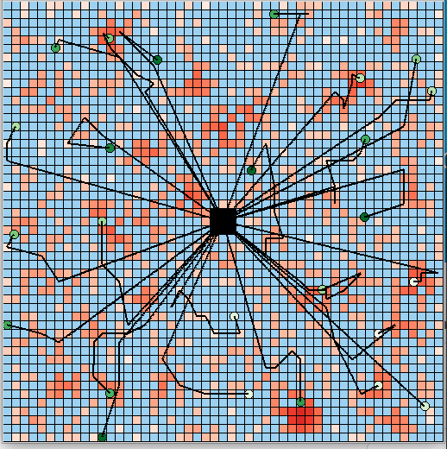
Fig. 1 – This image shows a simulation larger than the environment used in this paper. The shade of red represents the tree density.

Potential Field Overlay
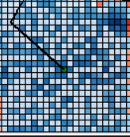
The UAV tree selection process makes use of potential fields, which are grids with different values, or potentials, in each cell. The information field holds the information value of each nearby cell, which is computed using the algorithms described in the next section. The proximity field is pre-defined, favoring closer cells over further cells. The two potential fields are combined with a weighted sum, and the UAV chooses the cell with the greatest value, represented as the darkest cell in Figure 2.
Fig. 3 – DBH Values plotted as a function of Tree Density (X axis) and Tree Height (Y axis)
Fig. 2 – Potential Field Grid
Overlaying potential fields allows for changes in UAV decision making to be easily implemented if additional constraints are placed or different forms of information are introduced.

Performance Metric
The performance metric of the simulation measures the usefulness of the collected DBH data points in predicting the rest of the forest, thus valuing intelligent selectivity.
The final trend function relating area density and height to DBH is computed with Gaussian regression [2]. Tree attribute data often display non-linear patterns. Gaussian regression, with its flexibility in capturing non-linear relationships between variables, excels in identifying these complex patterns present in tree attribute data. Traditional linear regression models might fail to capture the nuances and intricacies of tree attribute patterns, leading to less accurate DBH predictions.
The difference between the predicted trend function and the actual DBH values is evaluated using mean squared error. The MSE difference is the sole metric of the simulation.

Information Value Algorithms
This section describes different methods used to compute the information value of a given cell, which is the main influence of UAV tree selection.

Random Information Value
This algorithm is a control for a baseline comparison. The information value of each nearby cell is completely randomized.

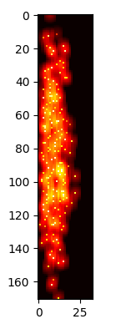
Information Value from Threshold
This algorithm does not consider the DBH value of the sampled tree, and only aims to sample trees across the range of tree heights and densities. A 2D grid with an X axis of density and Y axis of height keeps track of the information value of every (height, density) coordinate. The information of a coordinate is solely dependent on the previously collected coordinates.
Each sampled tree is plotted on the threshold as a (height, density) coordinate, signifying the coordinate now contains very little additional information, along with a small surrounding radius to show that the information value of nearby coordinates has also reduced. This is because to build an accurate trend function, a wide spread of tree heights and densities must be sampled. Gathering many data points with similar heights and densities does not provide any additional insight about the overall trend of the forest stand.

Information Value from Gaussian Regression
A crucial aspect of creating an accurate trend function lies in minimizing uncertainty. Gaussian regression guides agents to select trees that strategically minimize uncertainty in the developing trend function. By prioritizing trees that contribute the most to reducing uncertainty, Gaussian regression ensures that the trend function is based on the most informative and representative data points.
The information value of a tree can be quantified simply as the amount of uncertainty of the Gaussian regression at the respective (height, density, DBH) coordinate in 3D space.
An initial attempt at Gaussian regression of randomly selected points showed that there was very little correlation between density and DBH, high correlation between height and DBH. It also yielded a result with a constant and low uncertainty throughout the graph (Fig. 4), suggesting the model required tuning to yield accurate uncertainty data.

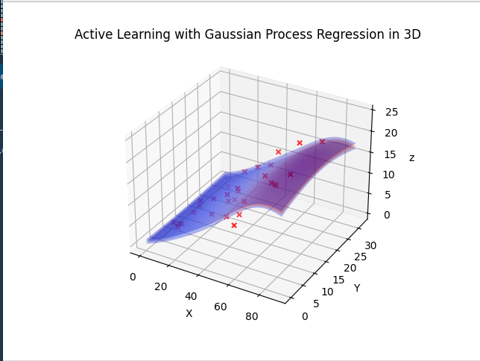
Fig. 4 – Initial Gaussian, X Height, Y Density, Z DBH (note the lack of correlation between Y and Z)
Since density did not have much of an impact on DBH values, it could be ignored during the tuning process and tuning could be done in 2D (height and DBH).
Different hyper parameters for the smoothness, length scale, noise level, and kernel width were tested with various number of training dataset sizes to yield smooth results with larger uncertainties occurring in areas that have fewer data points or in areas with data points that significantly diverge from the general trend of the previously collected data points. Figure 5 shows the Gaussian regression output with the final hyper parameters for various training dataset sizes.
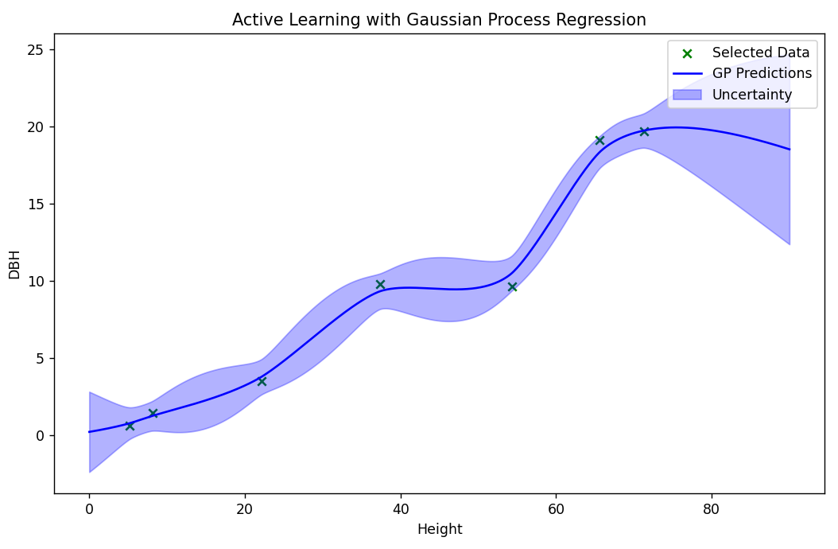
7 Data Points
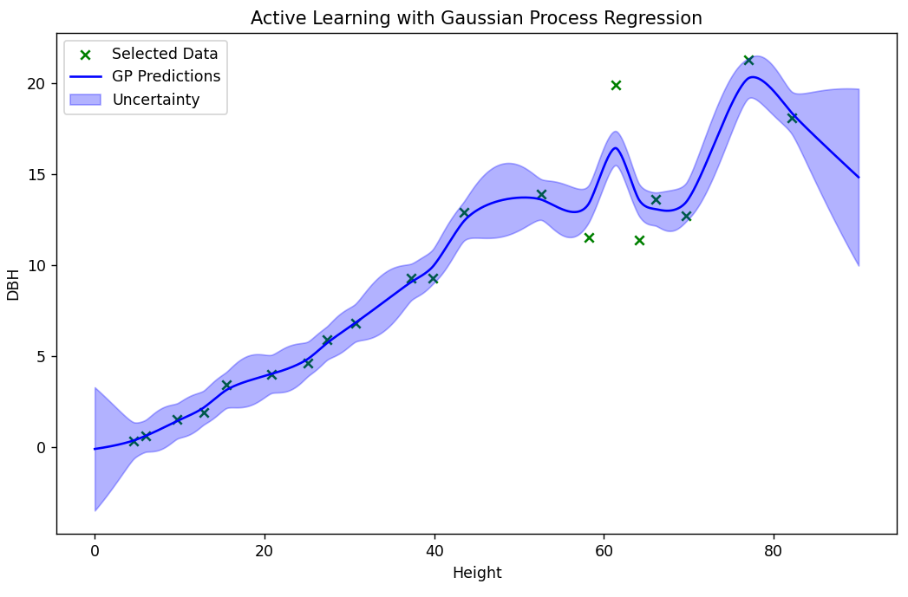
20 Data Points
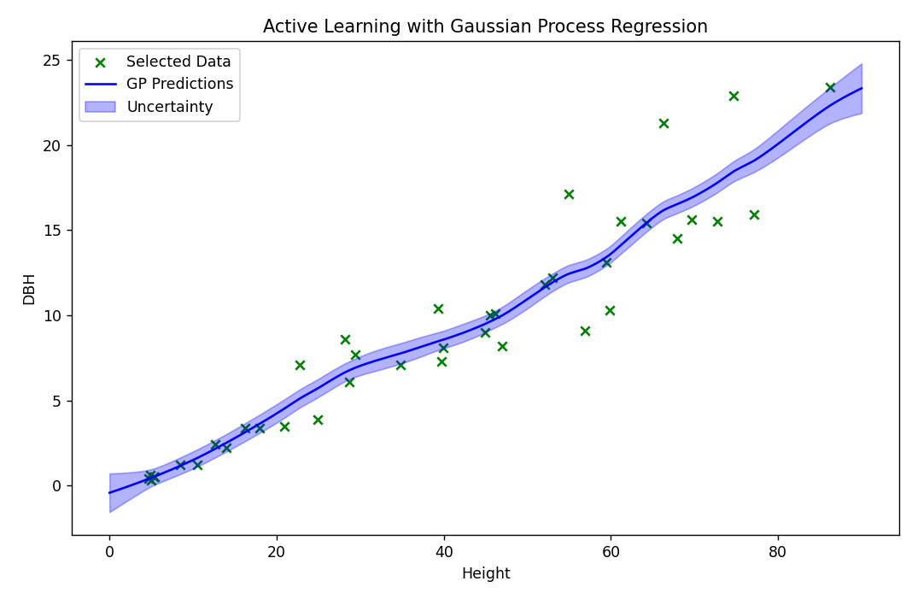
40 Data Points
Fig. 5 – 2D Gaussian Tuning

Results

Data
Thirty simulations were run with each of the information value algorithms, and the performance metric (MSE of DBH pred. and actual) was measured. Figure 6 exhibits box plots of the output metric values for each algorithm.
Gaussian regression as an information value algorithm performed better than the threshold algorithm. Both performed significantly better than the random information assignment algorithm.
Figure 7 exhibits the GPR fit on a set of selected points. The 2D tuning process proved to be effective in increasing the variance of uncertainty across the 3D graph, thus increasing intelligent selectivity.
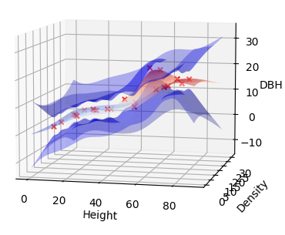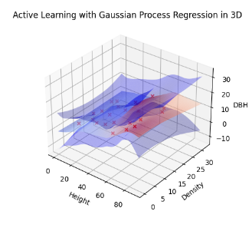
Fig. 6 – GPR 3D prediction graph
Fig. 7. – GPR 3D prediction graph
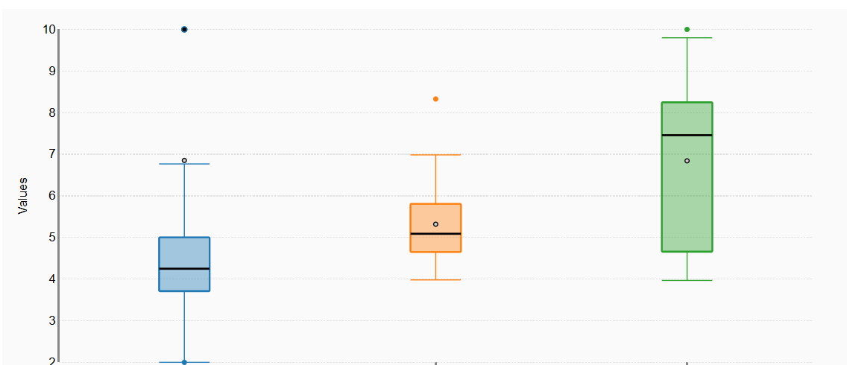
Fig. 7 – Box Plots for MSE in GPR, Threshold, and Random
Information Value Algorithms, respectively

Discussion
In conclusion, this study introduces a methodology combining a multi-agent system with Gaussian Process Regression (GPR) for accurate Diameter at Breast Height (DBH) prediction, crucial in understanding wildfire behavior. Our approach demonstrates the superiority of GPR-based information value algorithms in intelligent tree selection for DBH prediction compared to random and threshold-based methods. GPR can also be applied to other information foraging problems that attempt to determine trend functions between various variables.
Currently, GPR in swarms may not be scalable as the GPR repeatedly fits the whole set of selected points for each new point selection. Developing a strategy to optimize this process, such as only performing regression on segments of the selected dataset based on the new trees available, will allow for the scaling of this foraging algorithm to large forest areas with large numbers of UAVs.
Results show that density has no correlation with DBH values, despite our intuition. Tinkham [5] explains that the specific dataset used in this paper (Manitou Experimental Forest dataset) does not show a density and DBH correlation; however, most of the stand datasets he works with have a stronger correlation. Therefore, working with more datasets will help determine what tree attributes are most useful in predicting DBH values.
Currently, each agent greedily selects its next tree based on the DBH uncertainty from the Gaussian Process Regression. A more involved selection algorithm may yield better results. MCTS with the current greedy selection process as the rollout is one possibility. More work needs to be done on the selection algorithm.
The current tree selection process operates on a greedy approach, where each agent selects its next tree primarily based on the uncertainty of DBH values derived from Gaussian Process Regression. However, this simplistic selection method does not make the best decisions. Considering a more sophisticated selection algorithm could significantly enhance the efficiency and accuracy of tree selection.
One promising avenue for improvement involves implementing Monte Carlo Tree Search (MCTS) and retaining the current greedy selection process as the rollout strategy. MCTS is a decision-making algorithm known for its ability to explore a wider range of potential choices and paths, often leading to improved decision-making in complex scenarios. Integrating MCTS into the selection process could provide agents with a more comprehensive and strategic approach to tree selection.
Despite the potential offered by MCTS, it's crucial to note that further refinement and investigation are necessary for the selection algorithm. Fine-tuning and experimentation with various selection strategies might yield an optimal approach tailored to the specific requirements of the task at hand. Continuous exploration and iteration in refining the selection algorithm will be essential to developing an effective to trend construction strategy.
Overall, this research offers insights into the efficacy of swarm-based methodologies and GPR in DBH prediction, laying groundwork for more accurate wildfire behavior prediction.

References
- Swayze, N. C., Tinkham, W. T., Vogeler, J. C., & Hudak, A. T. (2021). Influence of flight parameters on UAS-based monitoring of tree height, diameter, and density. Remote Sensing of Environment, 263, 112540. https://doi.org/10.1016/j.rse.2021.112540
- Schulz, E., Speekenbrink, M., & Krause, A. (2018). A tutorial on Gaussian process regression: Modelling, exploring, and exploiting functions. Journal of Mathematical Psychology, 85, 1–16. https://doi.org/10.1016/j.jmp.2018.03.001
- Forsite Consultants Ltd - Forest Management Specialists, Western Canada. (n.d.). Www.forsite.ca. Retrieved August 18, 2023, from https://www.forsite.ca/
- Bernstein, J. (2011). Project Swarm How technological advances are inspired by swarming animals. https://jeremybernste.in/projects/swarm/printerfriendly.pdf
- Tinkham, W. (2023, November 9). Zoom meeting.

